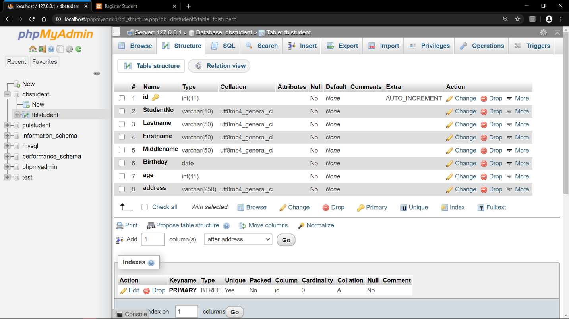

***Table Structure:*** *Table containing the required value names.*

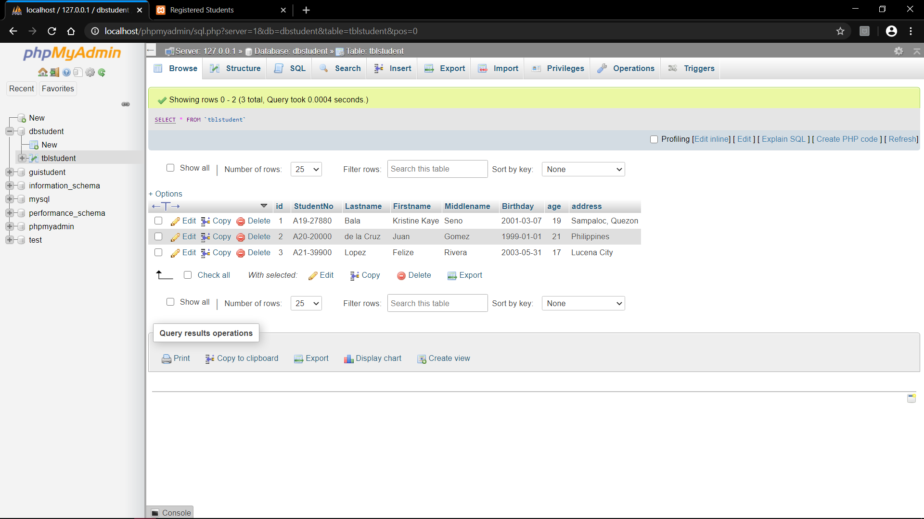

***Table Contents:*** *Table after 3 inputs*

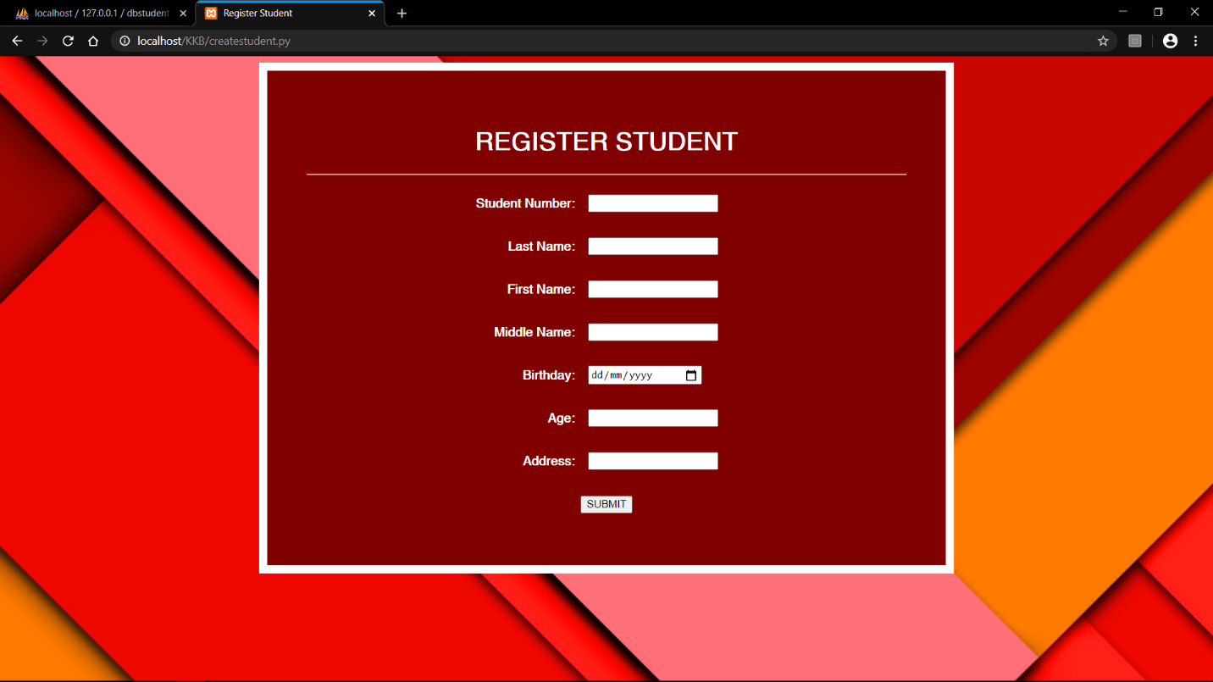

***CREATE: createstudent.py*** *output - access through localhost/KKB/createstudent.py*

*This is where user input data.*

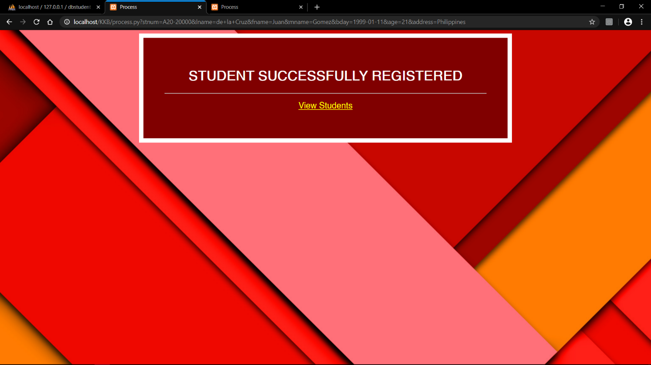

***process.py*** *output -access through localhost/KKB/process.py*

*This is automatically executed when you press Submit in createstudent.py*

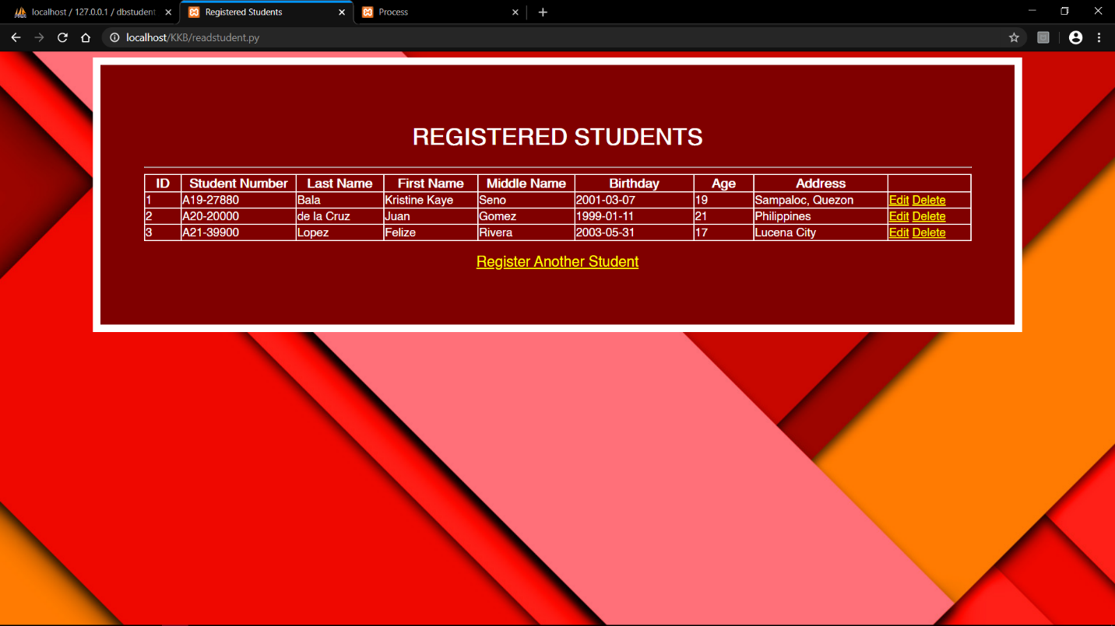

***READ: readstudent.py*** *output -access through localhost/KKB/readstudent.py*

*This is where you can see all the user input from the form. Includes Edit, Delete, and Register Another Student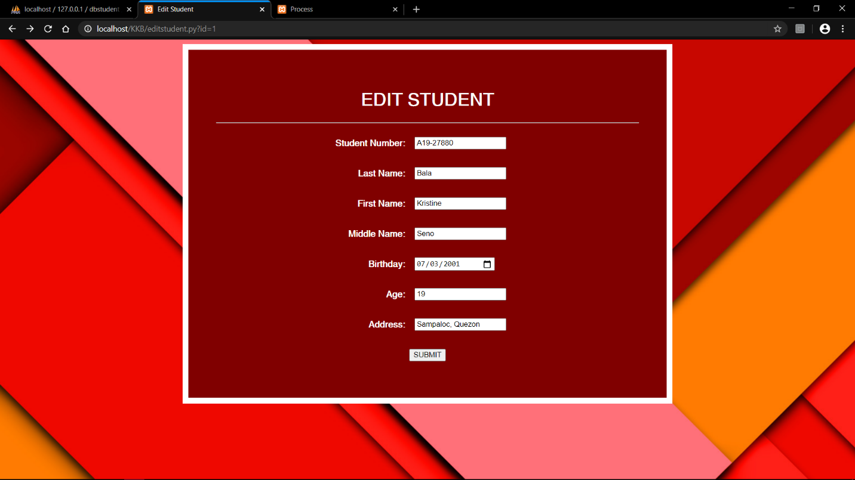*

***editstudent.py*** *output -access through localhost/KKB/editstudent.py*

*This is executed when you press Edit in readstudent.py*

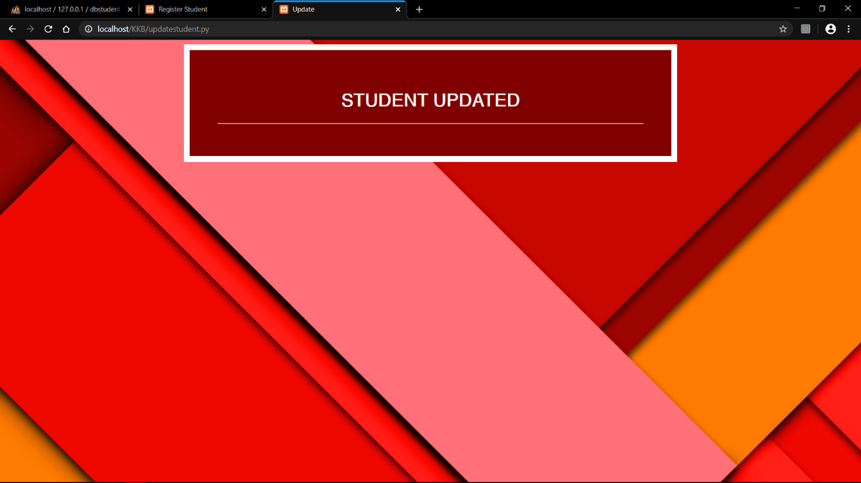

***UPDATE: updatestudent.py*** *output -access through localhost/KKB/updatestudent.py*

*This is automatically executed when you press Submit in editstudent.py*

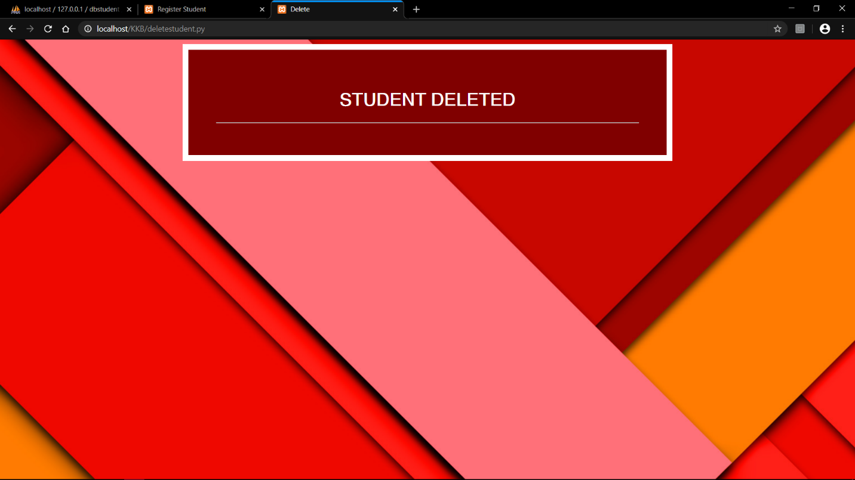

***DELETE: deletestudent.py*** *output -access through localhost/KKB/deletestudent.py*

*This is automatically executed when you press Delete in readstudent.py*

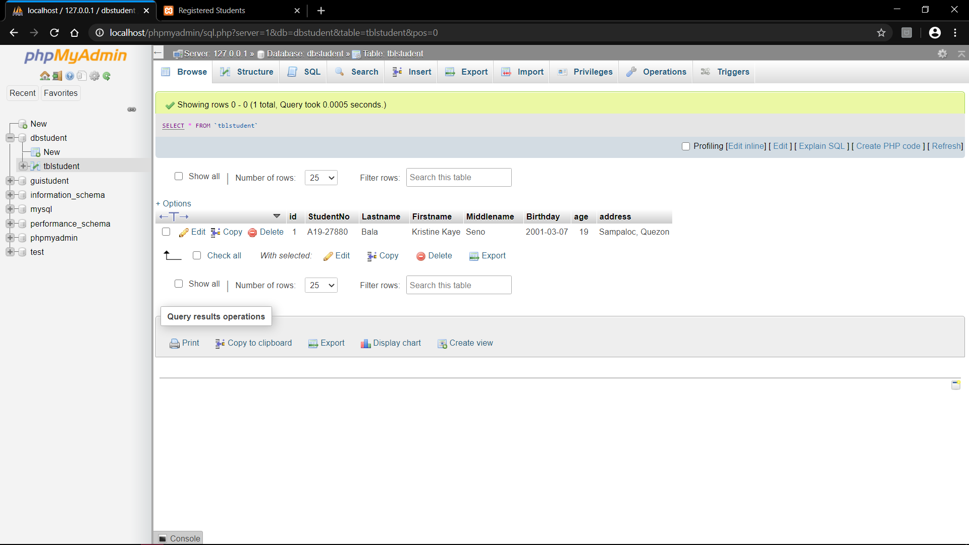

*First User input. Screenshot from localhost/phpMyAdmin*

*The data successfully passed in the database*

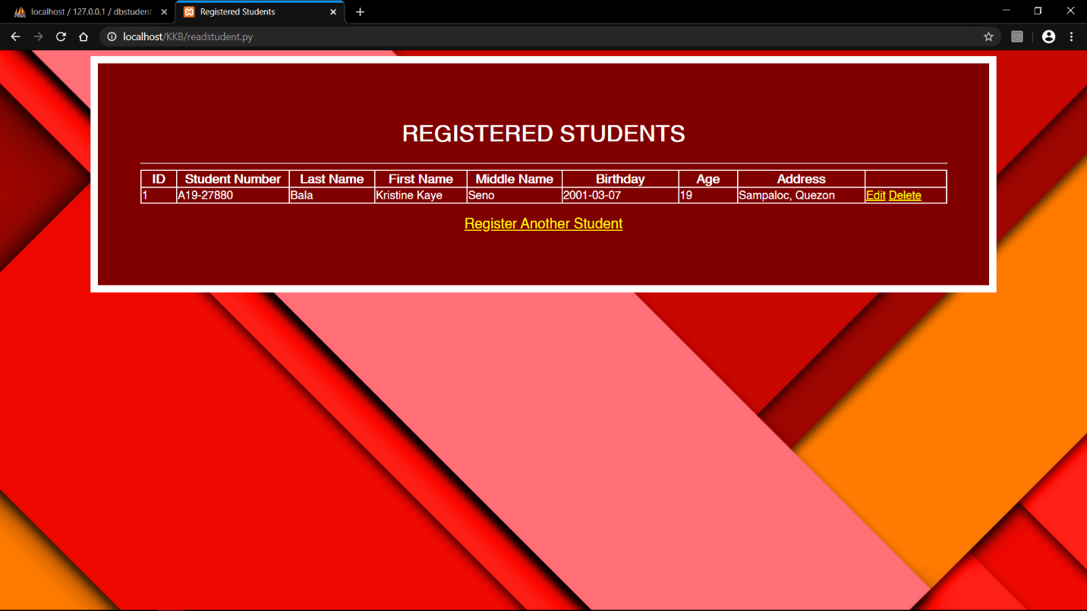

*First User input. Screenshot from localhost/KKB/readstudent.py*



*After Three User input. Screenshot from localhost/phpmyadmin*

*The data successfully passed in the database*

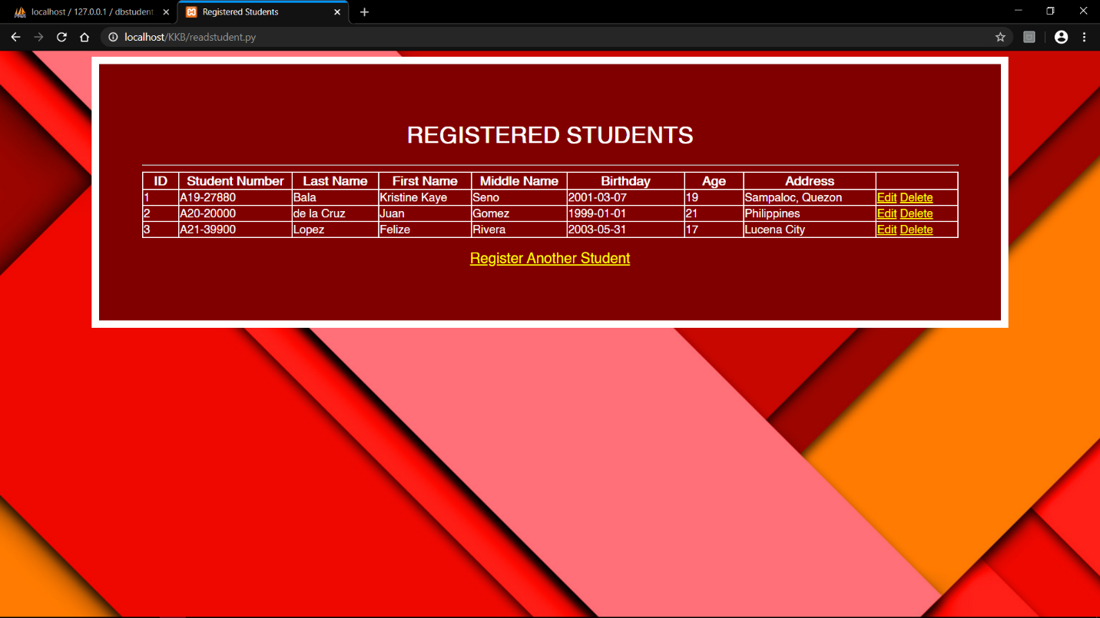

*After Three User input. Screenshot from localhost/KKB/readstudent.py*

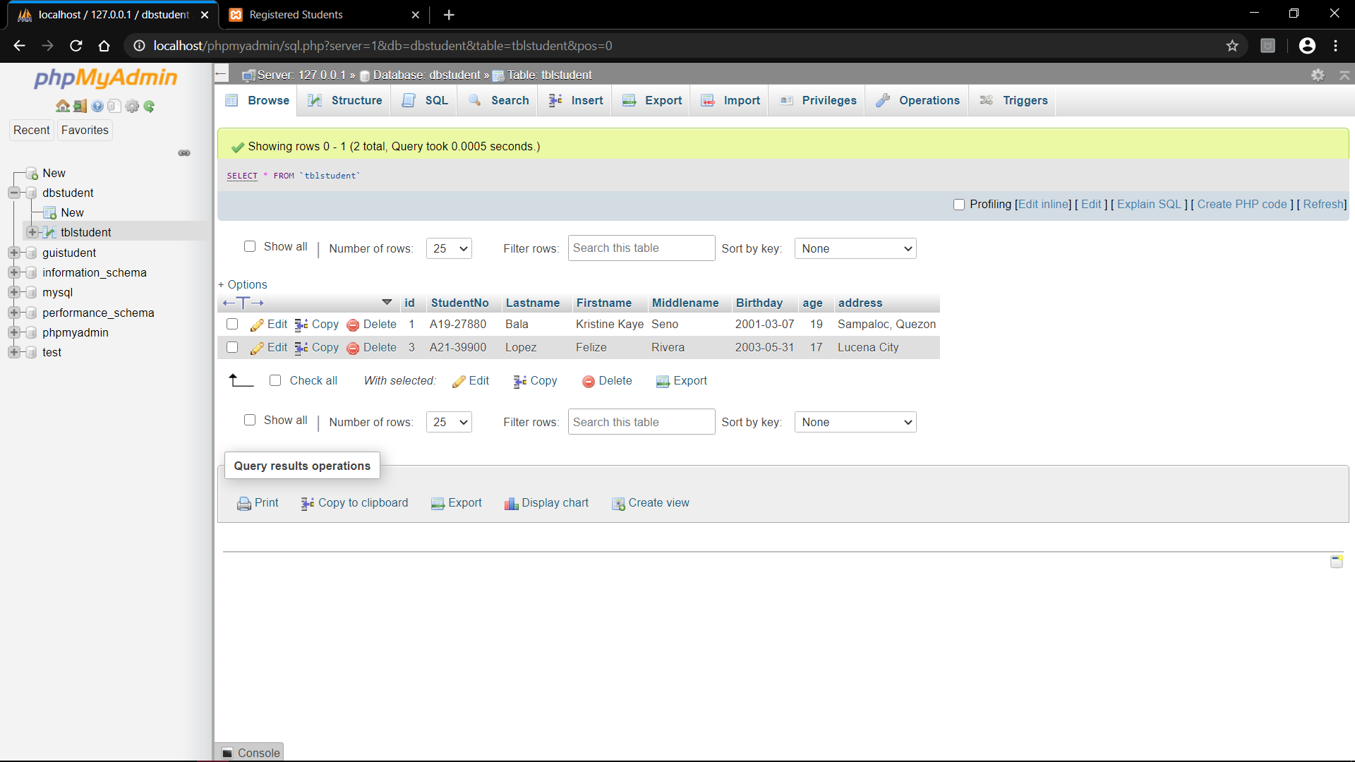

*After deleting id=2. Screenshot from localhost/phpMyAdmin*

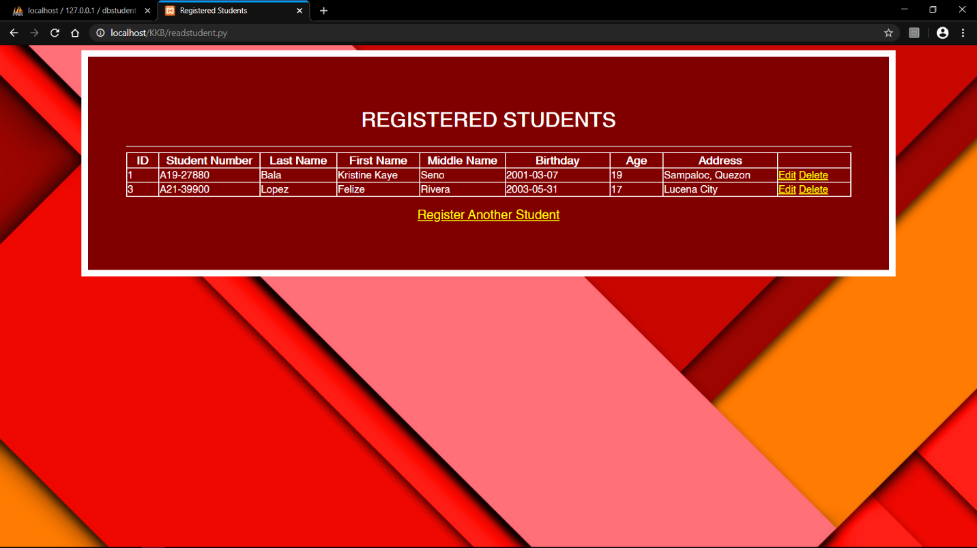

*After deleting id=2. Screenshot from localhost/KKB/readstudent.py*



*After deleting id=3. Screenshot from localhost/phpMyAdmin*

**

*After deleting id=2. Screenshot from localhost/KKB/readstudent.py*

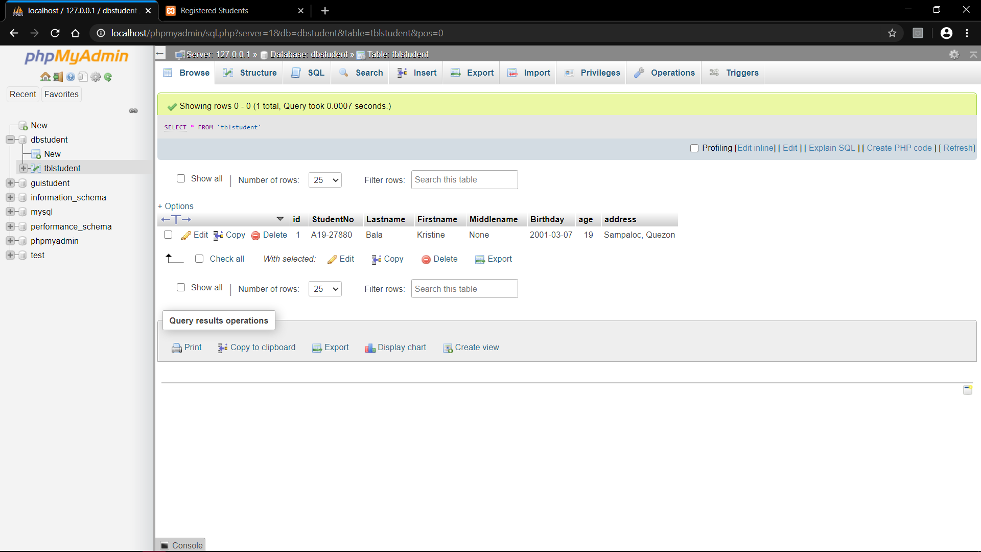

*After updating id=1. Screenshot from localhost/phpMyAdmin*

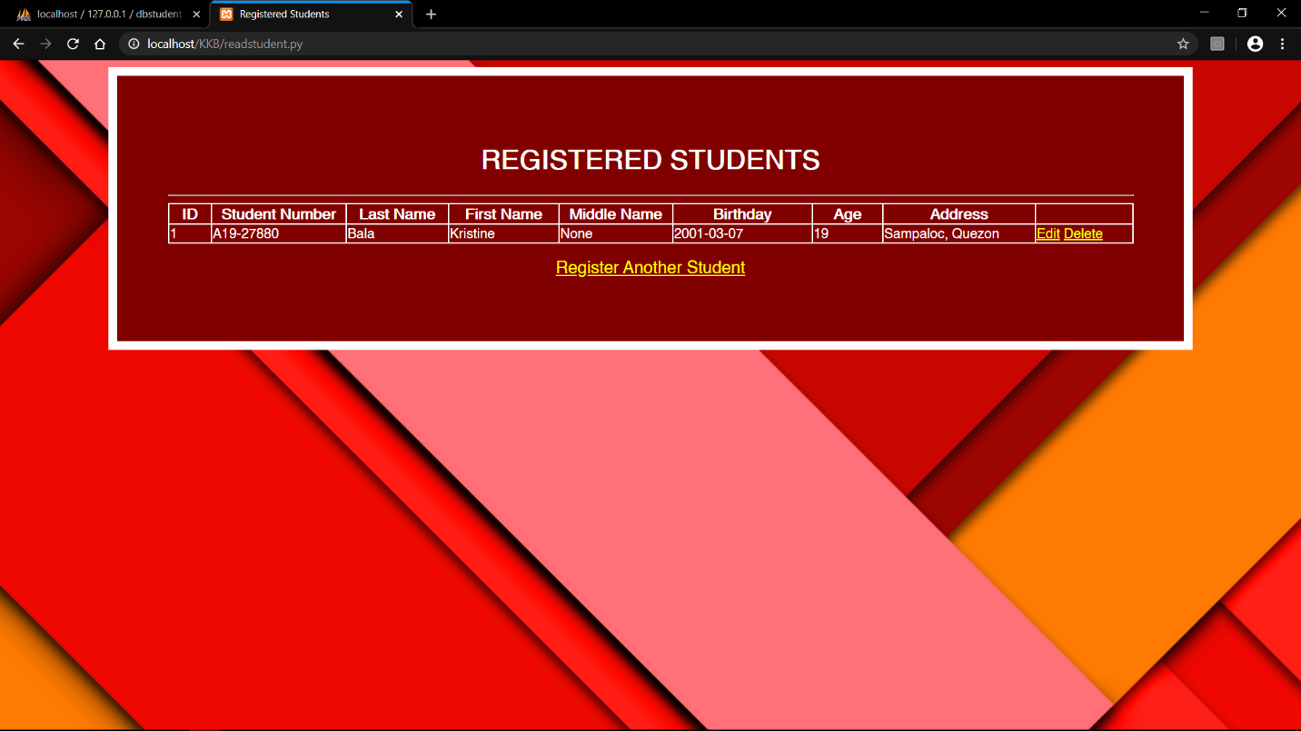

*After updating id=1. Screenshot from localhost/KKB/readstudent.py*